***SQL Codes***

1. Creating a Database

create database Gym_Management_System;

1. Using the Database

use Gym_Management_System;

1. Creating Table Member

create table Member(

id int(5),

Member_name varchar(200),

mobile bigint,

email varchar(100),

address varchar(100),

gender varchar(20),

age int(5),

gym_time varchar(50),

Aadhar bigint,

fees int(5),

emergency_name varchar(200),

emergency_contact bigint,

PRIMARY KEY (ID)

);

1. Description of Table Member

desc Member;

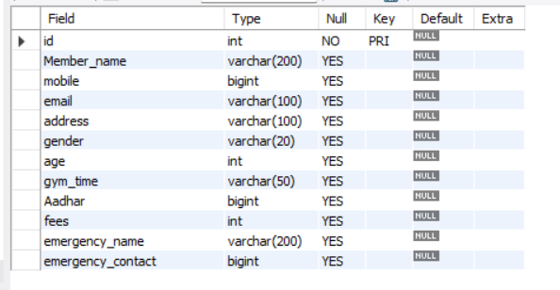

1. Create Table Payment

create table Payment(

id int(5),

Month varchar(50),

Amount bigint

);

1. Description of Table Payment

desc Payment;

